An online event management and matchmaking system for board game clubs

Contents

Planning 2
Background 2
The problem 2
The goal 2
The proposed solution 2
Components 3
Skills and resources 3
Alternative solutions 4
Method 5
Infrastructure 6
Stakeholders 6
Risks 7
Work Breakdown Structure (WBS) 8
Schedule 10
Work Completed 11
Literature 11
Development Environment 11
Reflection 13
References 15

Planning

Background
I am an avid board gamer and am a part of a local group that meet weekly in a pub for games, plus other ad hoc meet ups. The weekly evenings starts at 7.30 when there is a roll call of members saying which games they have brought. Once all the games are mentioned, people suggest games to play and form and join groups.

The problem
It's only a community group but we can easily get 50-60 people every week, essentially taking over the pub. This means that the roll call is chaotic with people not hearing games mentioned or not knowing what they are. Some people started to use Facebook to pre-arrange games with some using the polling feature. The polling feature has its issues (such as difficult use on mobile devices) and other non-Facebook users feel left out. There is also a problem of new people finding the whole roll call intimidating and some people end up without a group.

The goal
The goal of this project is to create a method of creating groups and matchmaking players at the start of the night to avoid the chaos of the roll call and to improve the overall experience of the night, making it more inclusive and friendly. It should allow games to begin sooner, extending the time available in the night for members to enjoy themselves.

The proposed solution
My intention is to create an online tool to allow members to list games that they have available on the night and to register interest in playing certain games. The system would display information about those games, such as a description and the number of players, etc. This would allow members to pre-arrange games and learn more about those games before playing. There would also be the option of more advanced matchmaking methods such as game and player preferences, random games, or skill-based matching. On the night, members would see the list of available games on a screen in the venue and could register interest then. The system would also integrate with the group’s website and social media, such as Twitter and Facebook, sharing details of proposed and arranged games for each event. This would allow new and non-members to be more informed at the start of the night, as well as promoting the events to members of the public.
Utilising my personal and professional knowledge of web development with HTML and JavaScript and expanding upon my level 3 Open University studies in Developing concurrent distributed systems (M362), Ebusiness technologies: foundations and practice (T320) and Fundamentals of interaction design (M364), I intend to develop a multi-tiered, distributed web application which is accessible on a range of devices and by a range of users.

Components
The system can be broken down into four main components:
- User Management
- Event Management
- Game/Library Management
- Match Management

Skills and resources
In order to be successful, this project will require familiarity of web technology and design principles, such as HTML and CSS, though it will need to be dynamic, so it will require knowledge of backend technology such as servers and databases. It will be important to not only create a functional system but one that is efficient. Therefore, a strong understanding of internet communication protocols will be essential. A knowledge of usability and accessibility will also be needed in order for the system to be adaptable to various different devices and users.
The system will require a form of server to host the application code, a method of processing matchmaking tasks, a type of database to store user, event and game data and a method of displaying the application to a range of different clients. Once developed, the system will need to be made available to its users in some form, which will require an awareness of web hosting platforms and application deployment.
I have some experience of web development through my OU studies, specifically with HTML, CSS, JavaScript and accessibility from Web Technologies (TT284); Java, XML and web services from T320; and web architecture and communication from M362.
I also have a lot of personal experience of programming and web development. Over the years I have gained competence in a number of programming languages, such as VBA for use in Microsoft Office documents, C for development on microprocessors like the Arduino, and C# when experimenting with video game development.
In particular, I have recently developed an online tool for the recording of scores for use with board games. The tool, called Pointi (http://pointi.firebaseapp.com), was developed using JavaScript and JQuery and utilised a number of frameworks to allow for the online sharing of data.
As a student, I have access to the GitHub education pack, which includes discounts on several web development tools, such as cloud hosting and DNS management. This would allow me to use professional tools for this project without any cost.
Professionally, I have recently undertaken a large amount of work in developing and maintaining an online portal for students and applicants at my workplace. Development is done within a specialist piece of student record database software, which generates web pages on the fly, so it is necessary to know the particular templating language as well as the desired HTML output, plus knowledge of database languages like SQL, to retrieve the appropriate data.
Following my studies in IT project and service management (M258), I have achieved foundation certificates in ITIL IT service management and PRINCE2 project management. This has given me a particular insight into the project process and appreciation of risk and issue management.

Alternative solutions
Option | Advantages | Disadvantages
Do nothing | Simplest solution  No requirement for technology, so is most inclusive | Problem likely to get worse as group expands
Paper-based:  Members write down games that they have brought and other members join games by signing their names on the paper | Simple to implement  Facilitates a basic form of matchmaking without the difficulty of verbally listing games | Not dynamic  Does not facilitate pre-arrangement of matches  Would still involve a lot of physical interaction with a large amount of people in a small space, continuing the challenge of being able to find games in a reasonable timeframe.
Social media:  Expand the usage of social networks, Facebook or Twitter, to require the displaying of games and arranging of matches on one or both services | Facebook and Twitter already provide polling functionality  Already used by some  Already includes social / community profiles and communication  Facebook already provides event management | Some users do not use Facebook or Twitter  There is some opposition to social networks and/or their policies  Does not assist in matchmaking, only listing of games and ‘polling’ of interest  Facebook polling does not work fully on mobile devices  Does not easily provide information about the games
Expansion of existing software:  Develop an add on to existing blog or bulletin board packages such as Wordpress or phpBB | Already includes social / community profiles and communication  Established development support and community  Would only need to develop matchmaking and game library functionality | Significant reliance upon 3rd party software and their updates and security  Increased complexity of development and maintenance – requirement to develop in very specific ways in order for add-on functionality to work  Client does not currently use software which can be expanded upon, so would involve migration of current website
Due to the above disadvantages, I believe that a bespoke piece of software which addresses the particular problems of the client, and can be made as small or large as necessary, would be the most appropriate option.

Method
In deciding an appropriate development lifecycle and process model, I’ve considered the following questions:
- What application domain does the project belong to? This application would be in the hobby and entertainment sector, but could possibly be used by businesses for event management.
- What is the type of application for this project? The application will be an interactive, web-based tool used to manage events and matches.
- What is the application's purpose? The purpose of the system is to be efficient at organisation and informative in order to improve the experience of an event.
- How robust does the application need to be? The application is not safety critical and, if it is not available, the group can revert to the current process. If the system is later used by wider groups or businesses who relied on it and had no alternatives, then the robustness would be a greater concern.
- How complex is the application? How complex is the project? The application architecture will not be that complex as it will be a fairly standard 3-tier website structure. The most complicated aspects of the application will be any intelligent matchmaking process that is developed and the external connection to retrieve game information.
- Are representative users readily available to the project team? The group contains a few active and regular members who would be closely involved in the project. They are normally available, in person, weekly, plus available online more frequently.
- How much uncertainty (of any kind) is there in the project? In terms of product uncertainty, the basic requirements of the system are known but the specific requirements within the matchmaking and presentation are subject to change according to the group’s members. There is some process uncertainty as I develop my skills in the relevant programming languages and tools. There is also a small amount of resource uncertainty as I investigate the availability and appropriateness of servers, hosts and technologies.
- Are there any time pressures to deliver some business value? There are no external time pressures for this project but it would be advantageous to be able to show working versions of the application as soon as possible in order to illicit further user requirements.
There is certainty of the overall project requirements but not of the individual components of the application, particularly the look and feel. There is a large number of users with no defined project lead. The development methods are relatively well known but the knowledge required and resource availability are unknown. Therefore, the waterfall model would be unsuitable with such uncertainty.
As the core aspects of the system are strongly interlinked (users, events, matches and games), it would be unlikely that an incremental approach would provide any benefit as any early version would not include core functionality. Like-wise, an iterative+incremental model would not be suitable either.
Therefore, an iterative model would be most suitable for this project because early, basic, versions of the software can be used to narrow scope and further define requirements; then later iterations could be used to maintain user involvement and improve the effectiveness of the application through user testing.
I will also be utilising aspects of the Agile methodology to guide development, such as Personas and User Stories as well as Kanban task boards using Trello.com software.
For planning and management, I am using Project in a Box Planner software, which includes a Gantt chart visualisation of the schedule and also Risk and Issue logs. The issues log, specifically, will be used to record:
- Confirmed user requirements, which can be referenced in user stories and have any changes recorded.
- Requests for Change for when the user group requests changes after functionality has been implemented so that there is a record.
- Major Actions and Decisions, so that it can be seen when and why certain things happened.
- Risks, Assumptions, Issues and Dependencies.
- Requests “Outside of Specification” for functionality which will not be produced within the scope of this project but could be developed later.
This use of an issues log allows any changes or problems to be recorded and monitored, reducing the amount that needs to be remembered.

Infrastructure
To allow me to produce prototypes and iterations of the application as quickly as possible, it is important that I utilise technology that I am knowledgeable of and comfortable with.
I could continue my OU work with Java and Java Enterprise Edition, making use of an application framework such as JavaServer Faces. I would have recent OU experience of Java and a lot of supporting documentation but I have no experience of JavaServer Faces or production quality Java applications.
I could rely on my previous knowledge of PHP server scripting and develop the application using a MVC framework such as Laravel. PHP is very common with plentiful documentation and extensions but it has been several years since I last used it and I have no experience of PHP frameworks.
Instead, I have decided to develop a JavaScript application using frameworks on the client-side with a MVC framework such as Angular and on the server-side with an application framework such as Express or Meteor on the Node.js platform. An advantage of this is that, as JavaScript is prevalent in developing user interfaces, it would mean only using one programming language for each tier of the application, reducing risk of errors when trying to learn multiple languages. I could extend this idea further by utilising a JavaScript-based database tier, such as MongoDB. The Node.js platform also includes extensive add-on libraries, npm and bower, allowing a wide range of functionality to be added very quickly. I have recently utilised a similar infrastructure on a live application, so am more confident in its use.

Stakeholders
- Members of the group – using the application to take part in the group’s events
- Organisers of the group – using the application to organise events and promote the group
- Members of the public – use the application to get information about the games that the groups plays
- The venue – often a pub, is affected by the organisation and success of the group in attracting customers to the venue. Also affected by any use of their facilities such as projector.
- Other clubs / businesses – which may want to use the application for their events
- Resource providers – server hosts and game information services would be concerned with the usage of their systems.
The intention is to have informal meetings with the user group on a weekly basis and formal meetings with a select core group of members at the start and end of each iteration.

Risks
Some initial risks are identified below. More specific risks will be identified once development begins.
# | Risk | Importance / Impact | Likelihood
R1 | Client does not accept the final product | H | L
R2 | Client accepts product but there is little or no use of product | H | M
R3 | Product does not work as intended | H | M
R4 | Infrastructure fails (such as host or database) | H | L
R5 | Cost of infrastructure is prohibitive | M | L
R6 | Project scope becomes unmanageable | M | M
R7 | Chosen frameworks become unavailable | M | L
R8 | Chosen frameworks are more difficult to learn than expected | H | M
R9 | Other unexpected OU study or work impacts availability | M | L
R10 | Conflict between users over project requirements | H | H
R11 | Lack of cooperation from users | M | L
R12 | Unclear or incorrect requirements | M | M
R13 | Lack of access to game information from external resource | M | L
R14 | Unable to use projector in venue | L | L

In order to mitigate the most likely risks, which are almost all based on user involvement, I will need to make sure that the scope of the project is well defined before much work is undertaken to avoid confusion over requirements and features. I will try to maintain strong communication, partly through regular prototypes and updates, to keep the interest in the project high, as well as keeping the scope fresh in the users’ minds.

Work Breakdown Structure (WBS)
An initial structure of tasks and subtasks is shown below. This structure will be expanded as development continues and, in particular, following evaluation of each iteration. Although the project is continuous and iterative, I have grouped my tasks together by TMA submission as they are non-movable milestones and useful points of reference.
WBS Code | Name & Description
0 | TM470
1 | TMA01
1.1 | Module Start
1.1.1 | Module reading
1.1.2 | Project set-up - planner, project log, git repositories, accounts, etc
1.1.3 | Project plan
1.1.3.1 | Review of previous modules - (T227)
1.1.3.2 | Goals, Resources, Tasks
1.1.3.3 | Analysis & user requirements - Meeting with user group
1.1.3.4 | Personas, User Stories, Scenarios
1.1.3.5 | Initial Wireframes
1.2 | Set up development environment – IDE, server, software, frameworks
1.3 | TMA write up
1.4 | TMA 01 submission
2 | TMA02
2.1 | Initial Prototype
2.2 | (first iteration)
2.3 | Evaluation
2.4 | TMA write up
2.5 | TMA 02 submission
3 | TMA03
3.1 | (second iteration)
3.2 | (third iteration)
3.3 | TMA 03 write up
3.4 | TMA 03 submission
4 | EMA
4.1 | EMA final preparation
4.2 | EMA submission

Schedule
Below is a Gantt chart showing the expected timeframes for the above structure. I have added, in blue, events or tasks which will restrict my ability to complete project work, such as holidays and deadlines for my other OU module. Holidays, in particular, have also been highlighted throughout the plan as grey, “non-working” days. This helps me see those gaps more easily and be able to prepare for problems.
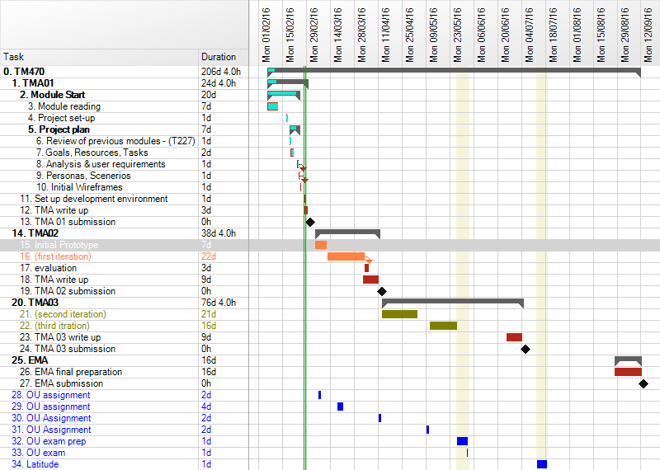

Work Completed

Literature
Fundamentally, my project is about developing and using web services, so it is very important to expand my understanding of web service architecture and HTTP. To that end, I have found Service Design Patterns: Fundamental Design Solutions for SOAP/WSDL and RESTful Web Services by Robert Daigneau (2011) very useful. The book was found in the Safari Books online collection and is written by a veteran of the online business technology industry less than 5 years ago, which means that it is relatively recent and covers newer topics. The book should help guide me in the right direction to produce an efficient and reliable application.
Although I am still currently reading it, it has immediately expanded upon my level 3 learning of web services by going into detail about the design of services, including when web services should and shouldn’t be used and the considerations needed to avoid problems. The book describes the various methods and styles of web service APIs and their uses and problems. Even though the book only mentions frameworks for Java and Microsoft C# environments, the theory is still very relevant for my usage of JavaScript.
As highlighted during my initial discussions with the user group, user interface and experience will be key to the success of this project in order to gain user acceptance. Responsive Web Design with HTML5 and CSS3 by Ben Frain (2012) provides a detailed look at how one can provide a leaner and better experience for users though the approriate use of simple CSS and HTML rather than bulky JavaScript.
Before developing HTML and CSS using techniques from the above book, it will also be important that the design of the application is usable. I will also be using Interaction Design: beyond human-computer interaction by Rogers, Sharp and Preece (2009) from the OU module M364. The book looks at more than just design of interfaces but the establishing of requirements and the evaluation of designs. I hope to explore this book in more depth than it was used during my OU study.

Development Environment
After deciding on using a full JavaScript-based environment, I undertook some exploratory work in setting up the relevant software. I am mainly using an online, cloud-based integrated development environment (IDE), Cloud9 (http://c9.io), to manage my code. The service provides a full, virtual, server on which I can install any neccesary software plus an intelligent code editor that supports a number of laguages. This is advantagous because it allows me to access my code whether I am at home or at work and it protects my personal laptop in case of software problems – I can just reinstall all the software with a few clicks. The service also includes live preview in multiple browsers and operating systems.
The risk involved is if there are any issues with internet connectivity. In this case, I have also set up a local development environment on my personal laptop in case of emergencies. This is where regular backups and git syncronisation is essential.
Software used:
- I have set up a Node.js server to run the application and deliver web pages. This provides a basic and easy to use server, which can be extended very easily.
- In order to utilise a MVC architecture, I have installed the Express.js Node.js web framework that makes it much easier to use HTTP correctly and produce an REST API to access the resources. By creating an API, it allows the front end interface to be completely separate from the application “business logic” and could allow other developers to use the application with different interfaces.
- I have installed the Angular.js front-end framework to provide application routing, data binding and improved client-server communication.
- For the database component of the application, I could have used MongoDB, which is a very common document-oriented database that used JSON-like documents. However, I have decided to use Orchestrate.io, which is a database web service that still uses a JSON object store but removes the need to set up and manage a full database system and it allows me to further explore web services and HTTP messages.
- I have installed socket.io, which enables real-time, bidirectional, event-based communication – useful at the beginning of a night when the games are displayed on the big screen, which could update in real-time as users are joing matches, rather than having to refresh the page.
- I have also installed Ungit as an easy, visual tool for maintaining the git repository of the project.
- Finally, I have installed nodemon, which monitors the code and automatically restarts the Node server when the code changes.
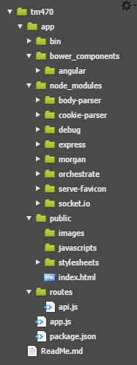
The image above shows the boiler-plate set up of the application after generating the structure using the Express-generator and installing the above software. By default, the generator uses the Jade javascript templating engine to render web pages which I will not be using, so I removed the template views (though may be useful at a later point).

Reflection
As I have been coming closer to the TMA deadline, I have been quite concerned about what I have and haven’t done. My original plan was to have complete requirements, personas and user stories but all the work I have managed is some technical reading and the setting up of my development environment. This makes me feel that I have done nothing, however, I do feel an accomplishment in selecting and installing the relevant software and learning and using more git.
It wasn’t until I wanted to reflect that I actually read the module study materials on evaluations, which, I think, would have helped me much more if I had read earlier so that I could better monitor my performance as I went. Therefore, considering Reflection after Action:
- What went well? What can I learn from that for the rest of my work on this module?
By selecting software and a programming language that I was comfortable with and having set up the basic structure for the application, I feel confident in my ability to rapidly prototype and develop effectively. I should not try to find lots of fancy new tools or libraries until I am ready to expand my prototypes. This will make sure that I remain confident in my workspace.
- What didn’t go so well? How did I recover from my problems? What can I learn from that for the rest of my work on this module?
Initial over-complication - before beginning the project planning, I had several different tools in mind to use for planning and project management and really wanted to take advantage of my PRINCE2 training, even though I knew that PRINCE2 was not really appropriate for this scenario. I also wanted to use the modern aspects of Agile but quickly drowned in reading about different styles and tools. I realised that just writing things down would go most of the way in planning. I need to make sure to keep writing as many thoughts as possible. Below is a snippet from my initial project log.
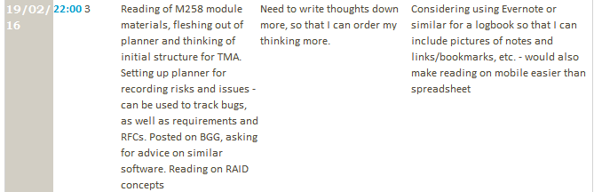
- Have I reached an acceptable standard, both according to what the module team and my tutor have told me and according to my own judgement?
Having re-read my assignment, I think that the standard of work is acceptable but could be better. I want to take more time in my next assignment to plan my time more effectively.
- Have I met the learning outcomes for this piece of work?
I do believe that I have successfully identified my problem, my goal and my skills and resources, though I don’t think that I have necessary written about them in the best manner. I have found relevant sources of information but have not had enough time to fully read them. I am also concerned over the legitimacy of blog posts about JavaScript libraries as relevant academic sources, so have not fully explored those that I’ve found. I understand that I have produced a lot more content than the word guide and am concerned that this implies a lack of communication skill but I cannot see how I could reduce my word count without removing important explanations for my actions.
- If not, what am I going to change?
I will make an effort to read more of my literature rather than spend time watching TV or reading technology news, making sure to make appropriate notes. I will also try to be more succinct and if I am more relaxed in my writing, this may be a lot easier.

References
Daigneau, R. (2012). Service Design Patterns. 1st ed. [ebook] Upper Saddle River, NJ: Addison-Wesley. Available at: http://proquestcombo.safaribooksonline.com.libezproxy.open.ac.uk/9780321669636 [Accessed 29 Feb. 2016].
Frain, B. (2012). Responsive web design with HTML5 and CSS3. Birmingham: Packt Publishing Ltd.
Preece, J., Rogers, Y. and Sharp, H. (2002). Interaction design. New York, NY: J. Wiley & Sons.

